Industry Oriented Mini Project Report
on

MACHINE LEARNING BASED HEART STROKE PREDICTION SYSTEM
Submitted in partial fulfilment of the requirement for the award of degree
Bachelor of Technology
in
Computer Science and Engineering
by
DAMARAGIDDA PAVAN KUMAR–22J21A0538
GADADAS PUJA-22J21A0553
CHEGURI SIRI-22J221A0530
BHUPATHI SANJAY-22J21A0518

Under the Supervision
of
Mr.L.NAGENDER KUMAR_{,,,M.Tech,}
Assistant Professor


Department of Computer Science and Engineering

JOGINPALLY B.R. ENGINEERING COLLEGE
Accredited by NAAC with A+ Grade, Recognized under Sec. 2(f) of UGC Act. 1956
Approved by AICTE, Affiliated to JNTUH, Hyderabad and ISO 9001:2015 Certified
Bhaskar Nagar, Yenkapally, Moinabad (Mandal)
R.R (Dist)-500075. T.S., India

A.Y: 2024-25

JOGINPALLY B.R. ENGINEERING COLLEGE
Accredited by NAAC with A+ Grade, Recognized under Sec. 2(f) of UGC Act. 1956
Approved by AICTE, Affiliated to JNTUH, Hyderabad and ISO 9001:2015 Certified
Bhaskar Nagar, Yenkapally, Moinabad (Mandal)
R.R (Dist)-500075. T.S., India



CERTIFICATE

The seminar entitled “MACHINE LEARNING BASED HEART STROKE PREDICTION SYSTEM” that is been submitted by DAMARAGIDDA PAVAN KUMAR–22J21A0538 GADADAS PUJA-22J21A0553 CHEGURI SIRI-22J221A0530)BHUPATHI SANJAY-22J21A0518in partial fulfilment of the award of Bachelor of Technology in Computer Science and Engineering to Jawaharlal Nehru Technological University Hyderabad. It is record of bonafide work carried out under our guidance and supervision. In my opinion, this report is of standard required for the degree of Bachelor of Technology.

PROJECT SUPERVISOR HEAD OF THE DEPARTMENT
Mr. Mr .L. Nagender Kumar ,_{B.tech.,M.Tech.} Dr. T. Prabakaran _{B.E, M.E., Ph.D.,}
Associate Professor Professor

EXTERNAL EXAMINER

DECLARATION

We hereby declare that the Project entitled “MACHINE LEARNING BASED HEART STROKE PREDICTION SYSTEM”, submitted towards the completion of a Industrial Oriented Mini Project Work in the III-II B.Tech., CSE at Joginpally B.R. Engineering College, Hyderabad, is an authentic record of our original work.

DAMARAGIDDA PAVAN – 22J21A0538
GADADAS PUJA – 22J21A0553
CHEGURI SIRI – 22J21A0530
BHUPATHI SANJAY – 22J21A0518

ACKNOWLEDGMENT

We would like to express our sincere thanks to Dr. K V N Sunitha, Professor & Principal,
BVRIT HYDERABAD College of Engineering for Women, for her support by providing the
working facilities in the college
We would like to express our sincere thanks to Dr. B. Venkata Ramana Reddy, Professor & Principal, Joginpally B.R. Engineering College, Hyderabad, for his support by providing the working facilities in the college.

Our sincere thanks and gratitude to Dr.T.Prabakaran, Professor & HOD, Department of Computer Science and Engineering, Joginpally B.R. Engineering College, Hyderabad, for all timely support and valuable suggestions during the period of our project.

We express gratitude to our Project Coordinator Mr. Suresh Kampe, Assistant Professor, Department of Computer Science and Engineering, Joginpally B.R. Engineering College, Hyderabad, for his valuable suggestions and advices.

We are extremely thankful to our Project Supervisor, Mr .L. NAGENDER Kumar, Assistant Professor, Department of Computer Science and Engineering, Joginpally B.R. Engineering College, Hyderabad, for his constant guidance and encouragement throughout the project.

Finally, we would like to thank all Faculty and Staff of CSE department who helped us directly or indirectly. We wish to acknowledge our Parents and Friends for giving moral strength and constant encouragement.

DAMARAGIDDA PAVAN – 22J21A0538
GADADAS PUJA – 22J21A0553
CHEGURI SIRI – 22J21A0530
BHUPATHI SANJAY – 22J21A0518

ABSTRACT

Heart disease continues to be one of the leading causes of death globally, highlighting the urgent need for effective early diagnosis methods. Traditional diagnostic processes often involve invasive tests and time-consuming evaluations, which can delay timely intervention. To address this challenge, this project presents a machine learning-based approach for predicting the presence of heart disease using patient health data. The study utilizes a publicly available heart disease dataset containing important clinical features such as age, gender, chest pain type, resting blood pressure, cholesterol levels, fasting blood sugar, electrocardiographic results, maximum heart rate achieved, and exercise-induced angina, among others.

A comprehensive data preprocessing pipeline was implemented, including handling missing values, normalization of feature values, and feature selection, to ensure the dataset was clean and suitable for training predictive models. Several classification algorithms — namely Logistic Regression, K-Nearest Neighbours (KNN), Decision Tree, and Random Forest — were applied to build predictive models. The models were trained and validated using appropriate train-test splits and cross-validation techniques to avoid overfitting and ensure generalization to unseen data.

Furthermore, the project emphasizes the growing potential of artificial intelligence and data driven solutions in the healthcare sector, promoting better patient care through early disease prediction. By integrating machine learning models into clinical practices, there is a possibility to reduce diagnostic time, optimize healthcare resources, and ultimately improve patient outcomes

TABLE OF CONTENTS

CHAPTER CONTENTS PAGE No.
ABSTRACT ii
LIST OF FIGURES vii
LIST OF ABBREVIATIONS vii
1 INTRODUCTION 1
2 LITERATURE REVIEW 3 2.1 Inferences from Literature Survey 4
2.2 Open Problems in Existing System 4
3 REQUIREMENT ANALYSIS 5
3.1 Feasibility Studies/Risk Analysis 5
3.2 Software Requirements 6
3.3 System Use case 7
3.4 Actitvity Diagram 8
3.5 Sequence Diagram 9
4 DESCRIPTION OF PROPOSED SYSTEM 10
4.1 Architecture 10
4.2 Slected Methodology or Proposed System 11
4.3 Description of software for Implementation 13
4.4 Transition/Software to Operations Plan 14
5 IMPLEMENTATION DETAILS 15
5.1 Development and Deployment setup 15
5.2 Algorithms 16
5.3 Testing 17
5.4 Performance Analysis 18
6 RESULTS AND DISCUSSIOON 19
7 CONCLUSION 21
7.1 Conclusion 21
7.2 Future Work 21
7.3 Research Issues 22
7.4 Implementation Issues 22

REFERENCES 23
APPENDIX
A SOURCE CODE 24
B SCREENSHOTS 27
C RESEARCH PAPER 32

LIST OF FIGURES
FIGURE NO. FIGURE NAME PAGE NO.

  - Use case Diagram 7
  - Activity Diagram 8
  - Sequence Diagram 9
5.1 SVM Classifier 15
5.2 Hyperplane in 2D and 3D 16
5.3 Performance Evaluation 19
B1 implementation of code 24
B2 trained models 25
B3 running the app 26
B4 getting input data 27
B5 output 28
LIST OF ABBREVATIONS
CNN - Convolutional Neural Networks
SVM - Support Vector Machine
KNN - K Nearest neighbour

1.INTRODUCTION
Among various life-threatening diseases, heart disease has garnered a great deal of attention in medical research. The diagnosis of heart disease is a challenging task, which can offer automated predictions about the heart condition of a patient so that further treatment can be made effective. The diagnosis of heart disease is usually based on signs, symptoms and physical examination of the patient. There are several factors that increase the risk of heart disease, such as smoking habit, body cholesterol level, family history of heart disease, obesity, high blood pressure, and lack of physical exercise. A major challenge faced by healthcare organizations, such as hospitals and medical centers, is the provision of quality services at affordable costs.
1 The quality service implies diagnosing patients properly and administering effective treatments. The available heart disease database consists of both numerical and categorical data. Before further processing, cleaning and filtering are applied on these records in order to filter the irrelevant data from the database.
2 The proposed system can determine an exact hidden knowledge, ie, patterns and relationships associated with heart disease from a historical heart disease database. It can also answer the complex queries for diagnosing heart disease; therefore, it can be helpful to health care practitioners to make intelligent clinical decisions. Results showed that the proposed system has its unique potency in realizing the objectives of the defined mining goals.

TYPES OF CARDIOVASCULAR DISEASES

Heart disorders are a category of problems that affect the heart and blood vessels and are sometimes referred to as cardiovascular diseases (CVD). Coronary artery disease (CAD), which includes angina and infarction, is a type of cardiovascular illness. Another type of heart illness is coronary heart disease (CHD), which develops when plaque, a waxy substance, builds up inside the coronary arteries. Such arteries deliver plasma that is rich in oxygen to the cardiovascular system. When plaque begins to accumulate in these arteries, the resulting condition is known as atherosclerosis. The formation of plaque takes several years. This plaque might harden or rupture with the passing of time (break open). Plaque calcification gradually narrows coronary arteries, reducing the flow of oxygen-rich blood into the heart. If this plaque punctures, clots may form on its surface.
An arrhythmia, or irregular heartbeat, is a problem with the rate or rhythm of your heartbeat. Your heart may beat too quickly, too slowly, or with an irregular rhythm. It is normal for your heart rate to speed up during physical activity and to slow down while resting or sleeping. There are four types of arrhythmia. They are
- Ventricular fibrillation.

- Ventricular tachycardia.

- Premature ventricular beats (PVCs)

- Torsade’s de pointes.

It is understood that the best ECG lead for monitoring arrhythmias is V1. The patient's symptoms were related to a wide QRS complex tachycardia, and V1 is capable of distinguishing ventricular tachycardia (VT) from supraventricular tachycardia (SVT) with aberrant conduction.

2.LITERATURE SURVEY

[1] Data mining was used to conduct a survey of systems for predicting cardiovascular disease. The report addressed data mining's usage in pattern development to uncover patterns in patient data. This method bolstered and improved their preexisting health care plan. Their described algorithms had a limited scope and were designed to predict cardiovascular illness. They developed an association rule based on a real informational index and the patients' cardiac health records, which resulted in a high rate of accuracy.
[2] The recommended calculation that they performed addresses not only the problem of a large number of principles, but also the proper approval of guidelines backings. To facilitate determination as a preliminary task in the therapeutic database characterization, Kernel F-score Feature Selection was presented. The suggested KFFS strategy first converts healthcare information to binary capacity by increasing BFF & LINEAR skills. Second, the F-score equation, piece capacities of anon-directly separable set of data are transformed into a straight distinct element space, allowing for the determination of treatment datasets.
[3] Data mining classification methods, including DT, NB, & NN, are examined in depth on a Cardiovasculardisease database in a report titled "Enhanced Research of Heart Disease Diagnosis utilizing Data Mining Classification Techniques".
[4] Different research methods were evaluated for their precision of results. There was a one hundred percent success rate for Neural Networks, DT has a 99.62% successfulness, whereas Naive Bayes only has a 90% likelihood of success. According to their findings, Neural Networks are the most accurate predictors of heart disease among the three models. Lastly, they included two additional input variables, obesity and smoking status, to complete the model. Due to their significance in the diagnosis of cardiac disorders, these characteristics are applied to achieve more precise outcomes.
[4] Frames Recovery, ROI Picking, Feature Extraction, and SVM Classifier were all suggested by Sneha(2018) for the study of Echocardiograms, whereby an input video is given into the system and subsequently utilized for training. At 97.30%, the system's accuracy is DCM at 97.40%, ASD at 97.57%, and regular condition at 99.53 percent.
[5] Using techniques such as boosted, svm, k-nn, naive bayes classification, J48, & rf, Martin(2017) provide a method for diagnosing heart failure that persists over time. Unconventional methods using LOSO validating set evaluation yields 97.82% reliability for the models. 4 5
[6] The Fast Fourier Transformation is used to analyze time series and was suggested by Raid(2017) as part of a MATLAB-based system for recommending treatments for cardiovascular illness. Together with this, we use an Ensemble model that combines bagging, a synthetic neural network, ordinary least support vector machines, and a naive bayes classifier

2.1 INFERENCES FROM LITERATURE SURVEY
There are some logically strong inferences that can be made from the literature review. The thesis is to composite the ideology of using machine learning algorithms for the prognosis, diagnosis and study of heart diseases and their predictability, it is important to deal majorly with the kind of machine learning algorithms that would suit the purpose and be centric on the major objectives - being able to predict the presence of a heart disease in the most accurate possible way. The literature surveys conclude the use of Naive Bayes and Support Vector Machine algorithms for the prediction of heart diseases. There are two major parameters that are involved in understanding the suitability of the respective methodologies and they are - the time taken to execute the prediction process and the accuracy of the predictive result. It is clear through various studies and experimentations that the SVM classifier is the best of all the algorithms owing to the extremely high accuracy rates. But when it comes to the time taken to execute the predictive process, the Naive Bayes classifier reflects higher suitability since it takes the least possible time to execute the process.
From the above-mentioned literature works, it is clear that effective research on this topic has been done and many models have been proposed.
1. It is evident that the above-mentioned systems have their own pros and cons.
2. While some of the recent works involve hybrid technologies and provide better accuracy, they are still far from what is needed.
3. With higher accuracy, comes the need for low computational costs for low computational costs, high processing speed, and most of all,the convenience of use

2.2 OPEN PROBLEMS IN EXISTING SYSTEM
Although prediction results achieved are promising, these traditional approaches are still far from being highly accurate and efficient. The existing systems are simple and effective but are extremely vulnerable to impact Although prediction results achieved are promising, these traditional approaches are still far from being highly accurate and efficient.
The existing systems are simple and effective but are extremely vulnerable to impact. Moreover, state-of-the-art methods leverage only one algorithm which causes inaccurate results. This could lead practitioners to false assumptions and improper diagnosis and treatments provided to patients.

3 REQUIREMENT ANALYSIS

3.1 FEASIBILITY STUDIES/RISK ANALYSIS OF THE PROJECT
FEASIBILITY STUDY
The feasibility of the project is server performance increase in this phase and a business proposal is put forth with a very general plan for the project and some cost estimates. During system analysis, the feasibility study of the proposed system is to be carried out. For feasibility analysis, some understanding of the major requirements for the system is essential.
Three key considerations involved in the feasibility analysis are
● Economic feasibility
● Technical feasibility
● Operational feasibility
ECONOMICAL FEASIBILITY
This study is carried out to check the economic impact that the system will have on the organization. The amount of funds that the company can pour into the research and development of the system is limited. The expenditures must be justified. Thus the developed system as well within the budget and this was achieved because most of the technologies used are freely available. Only the customized products had to be purchased.
TECHNICAL FEASIBILITY
This study is carried out to check the technical feasibility, that is, the technical requirements of the system. Any system developed must not have a high demand 8 on the available technical resources. This will lead to high demands being placed on the client. The developed system must have modest requirements, as only minimal or null changes are required for implementing this system.
OPERATIONAL FEASIBILITY
The aspect of the study is to check the level of acceptance of the system by the user. This includes the process of training the user to use the system efficiently. The user must not feel threatened by the system, instead must accept it as a necessity. The level of acceptance by the users solely depends on the methods that are employed confidence must be raised so that he is also able to make some constructive criticism, which is welcomed, as he is the final user of the system.

3.2 SOFTWARE REQUIREMENTS SPECIFICATION DOCUMENT
Hardware specifications: to educate the user about the system and to make him familiar with it. His level of
● Stable Version of Google Chrome
● Higher RAM, of about 4GB or above
● Processor of frequency 1.5GHz or above
Software specifications:
● Google Collab
● PyStream

3.3 SYSTEM USE CASE

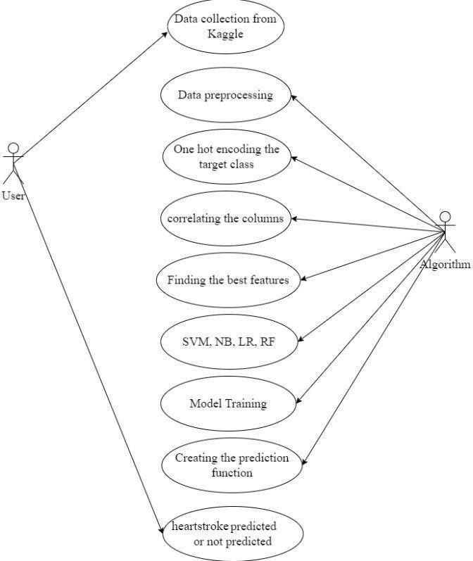
Fig 1.1 : Use Case Diagram

3.4 ACTIVITY DIAGRAM
An activity diagram is a kind of graphical representation that may be used to depict events visually. It is made up of a group of nodes that are linked to one another by means of edges.
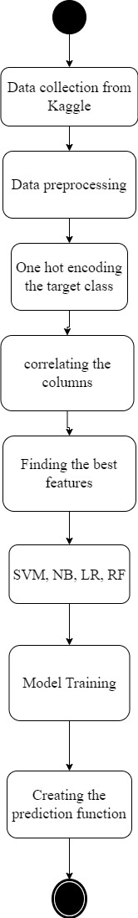
Fig 1.2 Activity Diagram

3.5 SEQUENCE DIAGRAM
The sequence diagram, also called the event diagram, describes the flow of messages in the system. It helps to visualize various dynamic parameters. He describes the communication between two rescue lines as a series of events arranged in time in which these rescue lines participated during the performance.
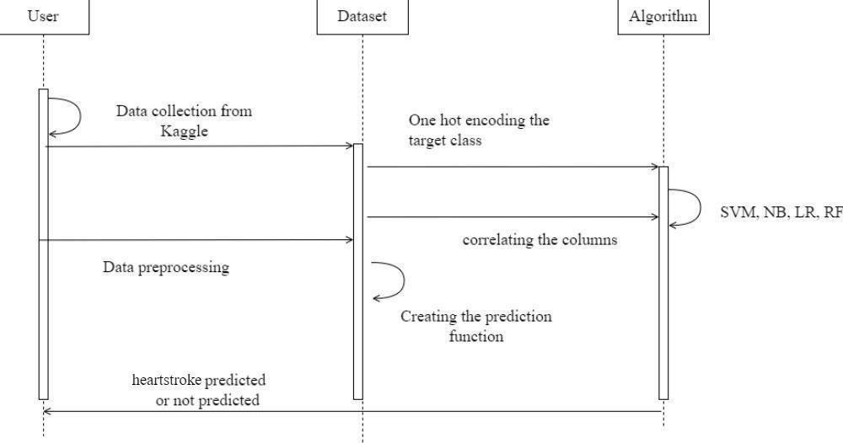
Fig 1.3 Sequence diagram

4 DESCRIPTION OF PROPOSED SYSTEM

4.1 ARCHITECTURE / OVERALL DESIGN OF PROPOSED SYSTEM

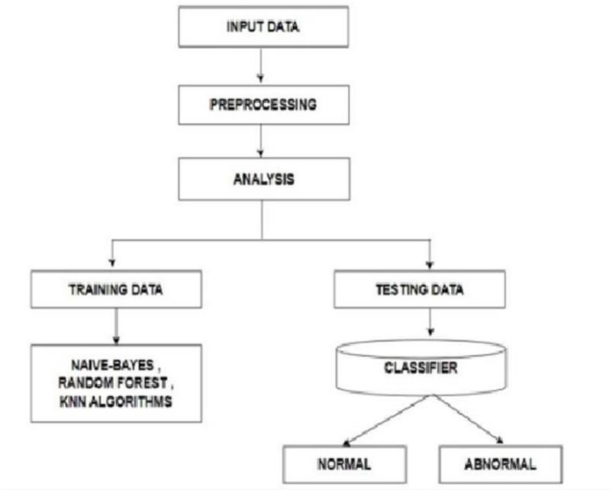
Data Collection:
The first step is to collect data from various sources such as electronic health records, medical imaging, and patient history. This data will be used to create a comprehensive view of the patient's health status.
Data Preprocessing:
The collected data needs to be preprocessed to remove noise and outliers. This may involve data cleaning, feature extraction, and feature selection.
Machine Learning Model:
The preprocessed data is fed into a machine learning model that uses various algorithms such as decision tree, random forests,support vector machine, Naïve bayes, K - nearest neighbour to predict the likelihood of a heart stroke. The model may also take into account the patient's demographics, medical history, and lifestyle factors.
Model Training and Validation:
The machine learning model needs to be trained using a dataset with known outcomes. The model's performance is then validated using a different dataset to ensure that it is accurate and generalizable.

Deployment:
Once the model has been trained and validated, it can be deployed in a real- world setting such as a hospital or clinic. The model will analyze patient data in real-time and provide predictions on the likelihood of a heart stroke
Flexibility:
The proposed system can use various ml techniques, such as SVM, LR, CNN, DT, and KNN, providing more flexibility in choosing the mostsuitable algorithm for a given dataset.
Improved performance:
With the use of advanced deep learning models, such as CNN or RNN, the proposed system has the potential to achieve better performance compared to traditional machine learning algorithms.
Incorporation of additional data sources:
For better categorization results, the suggested system may take into account other sources of data as demographics.
Real-time implementation:
The proposed system can be implemented in real-time, making it more suitable for practical use in healthcare compared toexisting methods that may have limitations in terms of processing speed

4.2 SELECTED METHODOLOGY OR PROCESS MODEL
Implementing a system for heart stroke prediction using various machine learningalgorithms such as K-Nearest Neighbor (KNN), Linear Regression, Support Vector Classification (SVC), Decision Tree, Random Forest, and Naive Bayes can be a powerfultool in predicting and preventing heart strokes.
The first algorithm that can be implemented is KNN, which works by finding the k nearest neighbors to a data point based on a similarity metric.
Linear regression is another algorithm that can be used for heart stroke prediction. This algorithm works by fitting a linear equation to the data, where the dependent variable is the output label, and the independent variables are the input features
SVC is a powerful algorithm for classification tasks, and it works by finding the optimal hyperplane that separates the data into different classes. The algorithm tries to find the hyperplane with the largest margin between the classes.
Decision trees are another algorithm that can be used for heart stroke prediction. This algorithm works by splitting the data into subsets based on the values of the input features
MODULE 1: Data Preprocessing
The data preprocessing module is a crucial part of any machine learning projects it involves cleaning and preparing the data before it is used for training the models.The first step in the data preprocessing module is to handle missing values. Medical data can often have missing values due to various reasons such as human error, data collection issues, or privacy concerns. The missing values can be handled by imputing them with the mean, median or mode value of the respective feature. In some cases, the missing values can be predicted using regression or other statistical techniques.
The second step is to encode categorical features. Medical data can include categorical features such as gender, smoking status, and hypertension. The third step is to normalize numericalfeatures. Medical data can include numerical features such as age, blood pressure, and cholesterol levels. The fourth step is to perform feature selection. Medical data can include a large number of features that may not all be relevant for predicting heart stroke.

MODULE 2: Model training
The model training module can be used to train the machine learning models using the pre-processed data. This module can include functions to train different machine learning models such as KNN, linear regression, SVC, decision tree, random forest, and Naive Bayes. The module can also include functions for hyperparameter tuning and cross- validation to improve the performance of the models. For example, hyperparameter tuning can be performed using techniques such as grid search or random search to find the best hyperparameters for the models. Cross-validation can be performed to evaluate the performance of the models on different subsets of the data. The trained models can be saved in separate files for testing and evaluation.
MODULE 3: Model Evaluation
The model evaluation module is a critical part of a heart stroke prediction project, as it allows us to test and evaluate the performance of the trained machine learning models on new data. The module should include functions to load the pre-processed data and the trained models, and use them to predict the output labels for the test data. It should also include functions to calculate the performance metrics such as accuracy, precision, recall, and F1-score for each of the models.
In conclusion, the model evaluation module is a critical part of a heart stroke prediction project, as it allows us to test and evaluate the performance of the trained machine learningmodels on new data. The module should include functions to calculate the performance metrics such as accuracy, precision, recall, and F1-score for each of the models. The metrics can be compared to choose the best model for heart stroke prediction, and the module can include functions to visualize the performance metrics using graphs or chartsto provide insights into the model's performance.

Module-3 WebApp
An important part of building a machine learning model is to share the model we have built with others. No matter how many models we create, if they remain offline, very few people will be able to see what we are achieving. That's why we should deploy our templates, so that anyone can play with them through a nice User Interface (UI). For this system, we build a single page web application with stream lit app as the UI of our system. It will take input and predict whether the user data given the person is having the chance of chronic heart disease or not in 10 years. Stream lit is an open-source app framework that lets you create web apps from your data scripts in minutes. No front-end experience required.

4.3 DESCRIPTION OF SOFTWARE FOR IMPLEMENTATION ANDTESTING PLAN OF THE PROPOSED MODEL/SYSTEM
Testing the model is an important step in heart stroke prediction as it evaluates the model's performance on new and unseen data. Here is a summary of the steps involved in testing the model for heart stroke prediction:
1. Split the data: The first step is to split the data into training and testing sets. The training set is used to train the model, while the testing set is used to evaluate the model's performance. The recommended split is usually 80:20 or 70:30 for trainingand testing, respectively.
2. Train the model: Next, the model is trained on the training set using the optimized hyperparameters and feature selection techniques. The model's performance isevaluated using appropriate evaluation metrics such as accuracy, precision, recall, F1-score, and area under the ROC curve.
3. Test the model: Once the model is trained, it is tested on the testing set to evaluate its performance on new and unseen data. The same evaluation metrics are used to evaluate the model's performance on the testing set.
4. Evaluate the results: Finally, the results are evaluated to determine if the model is performing well on new and unseen data. If the model's performance is satisfactory,it can be deployed for heart stroke prediction in clinical practice
REFINEMENT AND DEPLOYMENT OF MODEL
Refinement and deployment of a model for heart stroke prediction involves improving the model's performance and deploying it in a real-world setting. Here is a summary of the steps involved in refinement and deployment of the model:
1. Refinement: Once the model has been tested and evaluated, any necessary refinements are made to improve the model's performance. This could involve adjusting hyperparameters, improving feature selection, or exploring different algorithms or ensemble techniques. The model is then retrained and retested to evaluate its performance.
2. Validation: Before deployment, the model must be validated to ensure that it performs well on new data. This can be done using techniques such as cross- validation, bootstrapping, or hold-out validation. The model's performance on validation data is compared to its performance on the testing data to ensure that it generalizes well to new data.
3. Deployment: Once the model has been validated, it can be deployed in a real- world setting. This involves integrating the model into a software application or system that is used in clinical practice. The deployment process must be carefully planned and tested to ensure that the model is robust, reliable, and secure.
4. Monitoring and maintenance: After deployment, the model must be monitored and maintained to ensure that it continues to perform well over time. This involves monitoring the model's performance, updating the model if necessary, and addressingany issues or bugs that arise.

4.4 TRANSITION/ SOFTWARE TO OPERATIONS PLAN
● Scikit learn
● Tensor flow
● Keras
● pyTorch
● XGBoot
● Collab
● Stable Google Chrome
● Intel® Core™ i5 processor 8250U at 1.60 GHz or 1.80 GHz, 8 GB of DRAM.
● Disk space 2TB. 3. Operating System: 64-bit Windows 10 Pro
● PIP and NumPy: Ubuntu*, Python 3.6.2, NumPy 1.13.1, scikit-learn 0.18.2 Windows: Python 3.6.2, PIP and NumPy 1.13.1, scikit-learn 0.18.2 Intel® Distribution for Python* 2018.

5 IMPLEMENTATION DETAILS

5.1 DEVELOPMENT AND DEPLOYMENT SETUP
Input Design: The following factors should be considered while designing input for a comparison study on machine learning for Heart disorders diagnosis.
Data sources: In order to diagnose heart disease, it is necessary to identify which data sources wil lbe used, such as electronic medical records, Heart function tests, imaging data, and clinical data analysis.
Data Preprocessing: The system will need to perform data preprocessing in order to prepare the data for analysis, which will include data cleaning, data transformation, and feature engineering in order to prepare the data for analysis.
Feature engineering: Identify and extract from the data the key features that will be used to train the machine learning model based on the features found in the data. In some cases, it may be necessary to do this with automated feature engineering methods or with domain expertise in order to achieve this goal.
Data storage: Determine the appropriate storage mechanism for the input data, such as a database or data warehouse. This will ensure that the data is easily accessible and can be efficiently processed by the machine learning models.
Data integration: The aim of this project is to integrate data from different sources and formats in 25 order to create a unique dataset that can be used for the diagnosis of Heart disorders.
Output Design: When designing output for Heart disorder diagnosis using machine learning techniques, a comparative study, it is important to consider the following factors. Diagnosis and classification
Diagnose and classify: Heart disorders based on input data. A specific disorder, suchas fatty Heart, cirrhosis, or hepatitis, should be identified, along with its severity.

5.2 ALGORITHMS
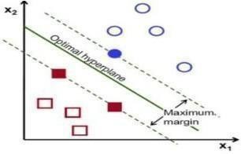
FIG 4.1: SVM CLASSIFIER
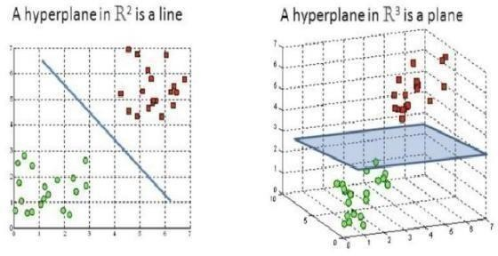
FIG 5.2: HYPERPLANES IN 2D & 3D
- Logistic Regression Algorithm:
Logistic regression is one of the most popular Machine Learning algorithms, which comes under the Supervised Learning technique. It is used for predicting the categorical dependent variable using a given set of independent variables.
Logistic regression predicts the output of a categorical dependent variable. Therefore the outcome must be a categorical or discrete value. It can be either Yes or No, 0 or 1, true or False, etc. but instead of giving the exact value as 0 and 1, it gives the probabilistic values which lie between 0 and 1.
- Random Forest Algorithm:
Random Forest is a popular machine learning algorithm that belongs to the supervised learning technique. It can be used for both Classification and Regression problems in ML. It is based on the concept of ensemble learning, which is a process of combining multiple classifiers to solve a complex problem and to improve the performance of the model.
As the name suggests, "Random Forest is a classifier that contains a number of decision trees on various subsets of the given dataset and takes the average to improve the predictive accuracy of that dataset." Instead of relying on one decision tree, the random forest takes the prediction from each tree and based on the majority votes of predictions, and it predicts the final output.
- K-Nearest Neighbour (KNN) Algorithm:
K-Nearest Neighbour is one of the simplest Machine Learning algorithms based on Supervised Learning technique. K-NN algorithm assumes the similarity between the new case/data and available cases and put the new case into the category that is most similar to the available categories. K-NN algorithm stores all the available data and classifies a new data point based on the similarity. This means when new data appears then it can be easily classified into a well suite category by using K- NN algorithm.

- Decision Tree Classification Algorithm:
Decision Tree is a Supervised learning technique that can be used for both classification and Regression problems, but mostly it is preferred for solving Classification problems. It is a tree- structured classifier, where internal nodes represent the features of a dataset, branches represent the decision rules and each leaf node represents the outcome.
In a Decision tree, there are two nodes, which are the Decision Node and Leaf Node. Decision nodes are used to make any decision and have multiple branches, whereas Leaf nodes are the output of those decisions and do not contain any further branches. The decisions or the test are performed on the basis of features of the given dataset.
- Support Vector Machine Algorithm:
Support Vector Machine or SVM is one of the most popular Supervised Learning algorithms, which is used for Classification as well as Regression problems. However, primarily, it is used for Classification problems in Machine Learning.
The goal of the SVM algorithm is to create the best line or decision boundary that can segregate n-dimensional space into classes so that we can easily put the new data point in the correct category in the future. This best decision boundary is called a hyperplane.

5.3 TESTING
Test Case 1: Input Validation
Description: The system should validate that input data is correct and complete.
Test Steps: Enter invalid data, such as a negative age or a missing blood pressure reading. Verify that the system provides an appropriate error message.
Test Case 2: Accuracy of Prediction
Description: The system should accurately predict the likelihood of a heart stroke.
Test Steps: Enter test data for patients who have had a heart stroke and patients who have not. Verify that the system accurately predicts the likelihood of a heart stroke for each patient.
Test Case 3: Sensitivity and Specificity
Description: The system should have high sensitivity and specificity.
Test Steps: Enter test data for patients who have had a heart stroke and patients who have not. Calculate the sensitivity and specificity of the system's predictions. Verify that the sensitivity and specificity are high.
Test Case 4: User Interface
Description: The system should have a user-friendly interface.
Test Steps: Evaluate the system's user interface to ensure that it is easy to use and understand. Verify that the system provides clear and concise information about the patient's predicted risk of a heart stroke.
Test Case 5: Performance and Scalability
Description: The system should perform well and be scalable.
Test Steps: Enter test data for a large number of patients. Verify that the system can handlea large number of requests without significantly impacting performance. Verify that the system can be easily scaled up to handle additional requests as needed.

5.4 PERFORMANCE ANALYSIS
The performance analysis for the heart stroke prediction project involves evaluating the performance of the system based on different performance metrics and comparing them to the project's goals and constraints. Here are some possible performance metrics that can be used for the analysis:
Detection Accuracy: The detection accuracy is a critical performance metric for the heart stroke prediction project. The accuracy measures how accurately the system can predict heart stroke cases. The accuracy can be calculated by comparing the predicted labels to the actual labels in the test dataset. The heart stroke prediction project should aim for an accuracy of at least 80%, and a higher accuracy is preferred. If the accuracy is lower than the target, the system's training data, model selection, or hyperparameters may need to be adjusted.
Response Time: The response time is the time taken by the system to make predictions. A shorter response time means that the system can make predictions faster, which can be critical in some applications. The response time can be measured using tools such as the Python time library or the Unix time command. The heart stroke prediction project should aim for a response time of a few seconds or less, depending on the application requirements. If the response time is longer than the target, the system's algorithm or hardware may need to be optimized.

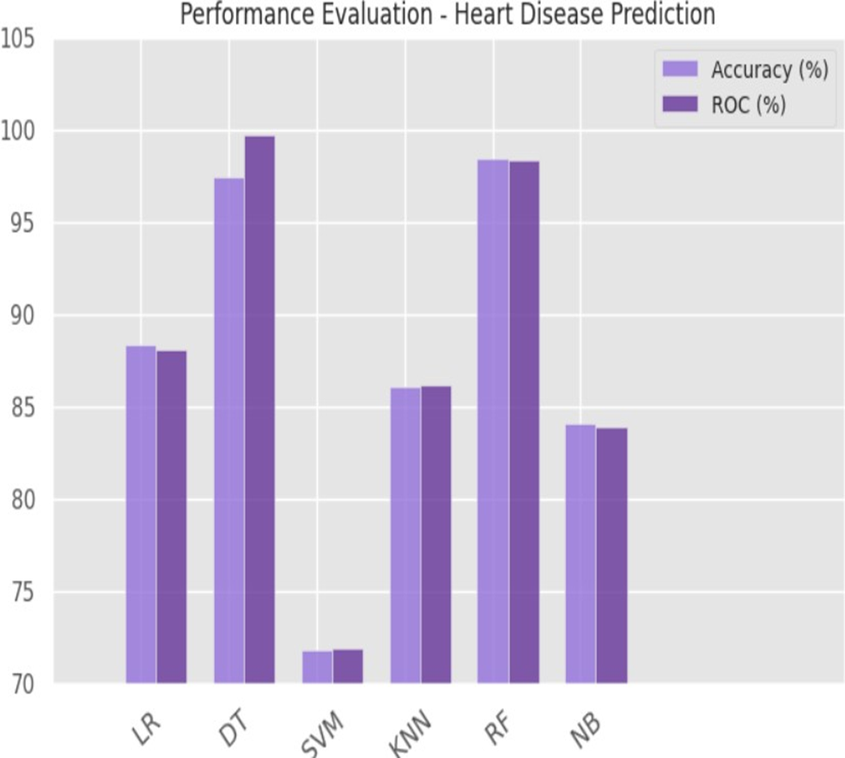
Fig – 5.3 – Performance Evaluation
In conclusion, the performance analysis for the heart stroke prediction project involves evaluating the system's performance based on different metrics such as detection accuracy, response time, resource usage, system uptime, and user satisfaction.

6 RESULTS AND DISCUSSION
In order to detect the likelihood that a user has heart disease, a ml model was developed in this research. For this machine learning model, the input data consists of 13 sets of human test results. During the processing and cleaning of this dataset, it was verified that no missing or invalid data values existed. The data set was broken down into two separate halves, x and y. Where the output (represented by the dependent variable y) is a function of the x parameter (which includes the 13 characteristics representing the various test outcomes). Standard Scaler was used to transform the x-axis value. Additional categories were created for the x and y variables: y-test, x-test, x-train & y- train.
These y-train & x-train were learned with the aid of the supervised learning methods CNN, K-NN, LR, SVM, & RF. Using varying values for n, the four methods were utilized to determine the accuracy %. The maximum accuracy is achieved by K Neighbours at n = 1, by CNN at n = 1 by SVM at n=1, and by Random Forest at n = 10. After conducting extensive tests, we settled on using SVM because of its reputation as one among the most reliable forecasting models.
Stream lit, an Api, was used to save and upload the SVM model to the web. We constructed an HTML website with Thirteen variables using Flask so that people may submit the findings of their different tests and let the model assess the likelihood that they have pulse rate. The model's results will be shown on aweb- based portal for the patient's convenience
TEST  ID | ALGORITHM | ACTUAL  OUTPUT | PREDICTED  OUTPUT | STATUS
1 | Logistic Regression | 100 | 85.0 | SUCCESS
2 | Random Forest | 100 | 80.0 | SUCCESS
3 | KNN | 100 | 85.0 | SUCCESS
4 | Decision Tree | 100 | 69.0 | SUCCESS
5 | SVM | 100 | 80.0 | SUCCESS

TABLE 6.1 : OUTPUT TAB

7 CONCLUSION AND FUTURE ENHANCEMENTS

7.1 CONCLUSION
Machine learning techniques have shown promising results in predicting heart stroke. Several studies have compared the performance of different machine learning algorithms in predicting heart stroke, and the results have varied depending on the dataset, features, and evaluation metrics used. In general, studies have found that ensemble methods such as random forests and gradient boosting classifiers perform better than other algorithms, such as logistic regression, support vector machines, and neural networks.
However, the performance differences between these algorithms may not be statistically significant in all cases. It is also important to note that the quality of the data and the choice of features can have a significant impact on the performance of the model.
Preprocessing and feature selection techniques, such as imputation, normalization, and feature engineering, can improve the performance of the model by reducing noise and extracting relevant information. Overall, machine learning techniques have the potential to improve the accuracyand efficiency of heart stroke prediction, and further research is needed to identify the mosteffective algorithms and feature selection techniques for different datasets and evaluation metrics. The prevention and disease progression can be aided by early identification.
Early diagnosis and the finding of important causal factors can be aided by machine learning technologies. The proposed technique generates a deep learning model that can predict cardiovascular illnesses and heart attacks.
The optimal solution for the job is the SVM algorithm. The model suggests that new machine learning algorithms usually lead to better prediction accuracy. The prevention and disease progression can be aided by early identification. Early diagnosis and the finding of important causal factors can be aided by machine learning technologies
The proposed technique generates a deep learning model that can predict cardiovascular illnesses and heart attacks. The optimal solution for the job is the SVM algorithm. The model suggests that new machine learning algorithms usually lead to better prediction accuracy.

7.2 FUTURE WORK
The project can be further enhanced by deploying the machine learning model obtained using a web application and a larger dataset could be used for prediction to give higher accuracy and produce better results..
- Incorporating new risk factors: Current heart stroke prediction models use a range of risk factors such as age, gender, blood pressure, cholesterol levels, smoking habits, and medical history
- Improving prediction accuracy: While machine learning models have shownpromise in heart stroke prediction, further research can explore new techniquesto improve the accuracy and reliability of the prediction models.
- Developing personalized prediction models: Personalized heart stroke prediction models can help healthcare professionals identify patients who are at a higher risk of heart stroke and provide targeted interventions.
- Evaluating the impact of prediction models: It is essential to evaluate the impact of heart stroke prediction models in real-world settings to understand their effectiveness in clinical practice.

7.3 RESEARCH ISSUES
Few Heart problems cannot lead to change in ECG images like; • Atrial fibrillation/flutter.
• Heart attack.
• Heart failure.
• Multifocal atrial tachycardia.
• Paroxysmal supraventricular tachycardia.
• Sick sinus syndrome.
• Wolff-Parkinson-White syndrome.
Common mistakes are: Left-right arm reversals lead to a negative complex in lead I with a negative P wave in lead I. They are one of the most common causes of right axis deviation on the ECG! Arm-foot switches lead to a very small or 'far field' signal in leads II or III.
Valvular defects cannot be detected using an ECG. Chest X-ray can be used to determine such defects. Therefore, an ECG can detect arrhythmia, myocardial infarction and also heart block but not valvular defects.
It cannot provide definite diagnosis of congestive heart failure. Prognosis during anesthesia or surgical procedures is unpredictable. Heart chamber wall thickness cannot be measured. Diseases of heart valves, endocardium, or pericardium cannot.

7.4 IMPLEMENTATION ISSUES
The Algorithms used in our project did not give a 100% accuracy, so the prediction isnot 100% feasible. Clinical diagnosis and diagnosis using our project may differ slightly because the prediction is not 100% accurate. Medical diagnosis is considered as a significant yet intricate task that needs to be carried out precisely and efficiently. The automation of the same would be highly beneficial. Clinical decisions are often made based on the doctor's intuition and experience rather than on the knowledge rich data collected from the dataset.

REFERENCES: -
[1] A. Singh et al., "Heart Disease Prediction Using Machine Learning Algorithms", 2020 International Conference on Electrical and Electronics Engineering (ICE3), pp. 452-457, February 2020.
[2] K. Hashi and M.S.U. Zaman, "Developing a Hyperparameter Tuning Based Machine Learning Approach of Heart Disease Prediction", Journal of Applied Science & Process Engineering, vol. 7, no. 2, pp. 631-647, 2020.
[3] Rahul Katarya and Polipireddy Srinivas, "Predicting heart disease at early stages using machine learning: A survey", 2020 International Conference on Electronics and Sustainable Communication Systems (ICESC), 2020.
[4] Davide Chicco and Giuseppe Jurman, "Machine learning can predict survivalof patients with heart failure from serum creatinine and ejection fraction alone",BMC medical informatics and decision making, vol. 20.1, pp. 1-16, 2020.
[5] A. M.A and P. A. Thomas, "Comparative Review of Feature Selection and Classification modelling", 2019 International Conference on Advances in Computing Communication and Control (ICAC3), pp. 1-9, 2019
[6] “How to read an Electrocardiogram (ECG). Part One: Basic principles of the ECG. The normal ECG.” [Online]. Available: http://www.southsudanmedicaljournal.com/archive/may-2010/how-to-read-anelectroc ardiogram-ecg.-part-one-basic-principles-of-the-ecg.-the-normal-ecg.html. [Accessed: 28-Apr-2019].
[7] F. Mendonca, R. Manihar, A. Pal and S. U. Prabhu, "Intelligent Cardiovascular Disease Risk Estimation Prediction System", 2019 International Conference on Advances in Computing Communication and Control (ICAC3), pp. 1-6, 2019.
[8] Ashir Javeed et al., "An intelligent learning system based on random search algorithm and optimized random forest model for improved heart disease detection", IEEE Access, vol. 7, pp. 180235-180243, 2019.
[9] Mohammad Shafenoor Amin, Yin Kia Chiam and Kasturi Dewi Varathan, "Identification of significant features and data mining techniques in predicting heart disease", Telematics and Informatics, vol. 36, pp. 82-93, 2019
[10] A. Gavhane, G. Kokkula, I. Pandya and K. Devadkar, "Prediction of Heart Disease using Machine Learning", 2018 Second International Conference on Electronics Communication and Aerospace Technology (ICECA), pp. 1275- 1278, 2018.

APPENDIX

SOURCE CODE
MODEL TRAINING
# Heart Stroke ClassificationThe dataset has 14 attributes:
# model_training.py
import pandas as pd
from sklearn.model_selection import train_test_split
from sklearn.preprocessing import StandardScaler
from sklearn.metrics import accuracy_score, precision_score, recall_score, f1_score
from sklearn.neighbors import KNeighborsClassifier
from sklearn.tree import DecisionTreeClassifier
from sklearn.linear_model import LogisticRegression
from sklearn.ensemble import RandomForestClassifier
from sklearn.svm import SVC
import joblib
# Load dataset
df = pd.read_csv("cleaned_merged_heart_dataset.csv")
# Features and target
X = df.drop("target", axis=1)
y = df["target"]
# Train-test split
X_train, X_test, y_train, y_test = train_test_split(X, y, test_size=0.2, random_state=42)
# Scaling
scaler = StandardScaler()
X_train_scaled = scaler.fit_transform(X_train)
X_test_scaled = scaler.transform(X_test)
# Models
models = {
"KNN": KNeighborsClassifier(),
"DecisionTree": DecisionTreeClassifier(random_state=42),
"LogisticRegression": LogisticRegression(max_iter=1000, random_state=42),
"RandomForest": RandomForestClassifier(random_state=42),
"SVM": SVC(probability=True, random_state=42)
}
# Training and saving
for name, model in models.items():
model.fit(X_train_scaled, y_train)
y_pred = model.predict(X_test_scaled)
print(f"\n{name} Results:")
print(f"Accuracy: {accuracy_score(y_test, y_pred):.4f}")
print(f"Precision: {precision_score(y_test, y_pred):.4f}")
print(f"Recall: {recall_score(y_test, y_pred):.4f}")
print(f"F1 Score: {f1_score(y_test, y_pred):.4f}")
joblib.dump(model, f"{name.lower()}_model.pkl")
# Save scaler
joblib.dump(scaler, "scaler.pkl")

CREATING AN UI
# app.py
import streamlit as st
import numpy as np
import pandas as pd
import joblib
# Load models
models = {
"KNN": joblib.load("knn_model.pkl"),
"Decision Tree": joblib.load("decisiontree_model.pkl"),
"Logistic Regression": joblib.load("logisticregression_model.pkl"),
"Random Forest": joblib.load("randomforest_model.pkl"),
"SVM": joblib.load("svm_model.pkl")
}
scaler = joblib.load("scaler.pkl")
st.title("🫀 Heart Stroke Prediction System")
st.sidebar.title("Model Selection")
model_choice = st.sidebar.selectbox("Choose a model", list(models.keys()))
# Input form
st.subheader("Enter Patient Details:")
age = st.number_input("Age", 1, 120, 50)
sex = st.selectbox("Sex", [0, 1]) # 0: Female, 1: Male
cp = st.selectbox("Chest Pain Type (0-3)", [0, 1, 2, 3])
trestbps = st.number_input("Resting Blood Pressure", 80, 200, 120)
chol = st.number_input("Cholesterol", 100, 600, 200)
fbs = st.selectbox("Fasting Blood Sugar > 120 mg/dl", [0, 1])
restecg = st.selectbox("Rest ECG", [0, 1, 2])
thalachh = st.number_input("Max Heart Rate Achieved", 60, 220, 150)
exang = st.selectbox("Exercise Induced Angina", [0, 1])
oldpeak = st.number_input("ST Depression", 0.0, 6.0, 1.0)
slope = st.selectbox("Slope of ST", [0, 1, 2])
ca = st.selectbox("Number of Major Vessels (0–3)", [0, 1, 2, 3])
thal = st.selectbox("Thalassemia (1 = normal; 2 = fixed defect; 3 = reversable)", [1, 2, 3])
# Prediction
if st.button("Predict Stroke Risk"):
input_data = np.array([[age, sex, cp, trestbps, chol, fbs, restecg,
thalachh, exang, oldpeak, slope, ca, thal]])
input_scaled = scaler.transform(input_data)
prediction = models[model_choice].predict(input_scaled)[0]
prob = models[model_choice].predict_proba(input_scaled)[0][1]
st.success(f"Prediction: {'Stroke Risk' if prediction == 1 else 'No Stroke Risk'}")
st.info(f"Probability: {prob * 100:.2f}%")

SCREENSHOTS

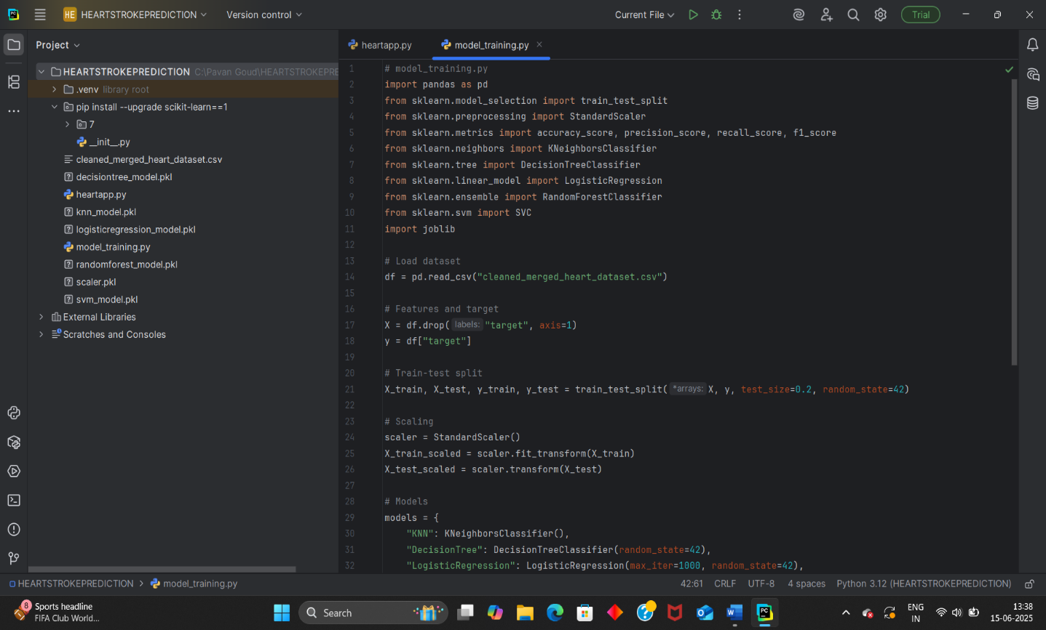

Fig:B1 – implementation of code

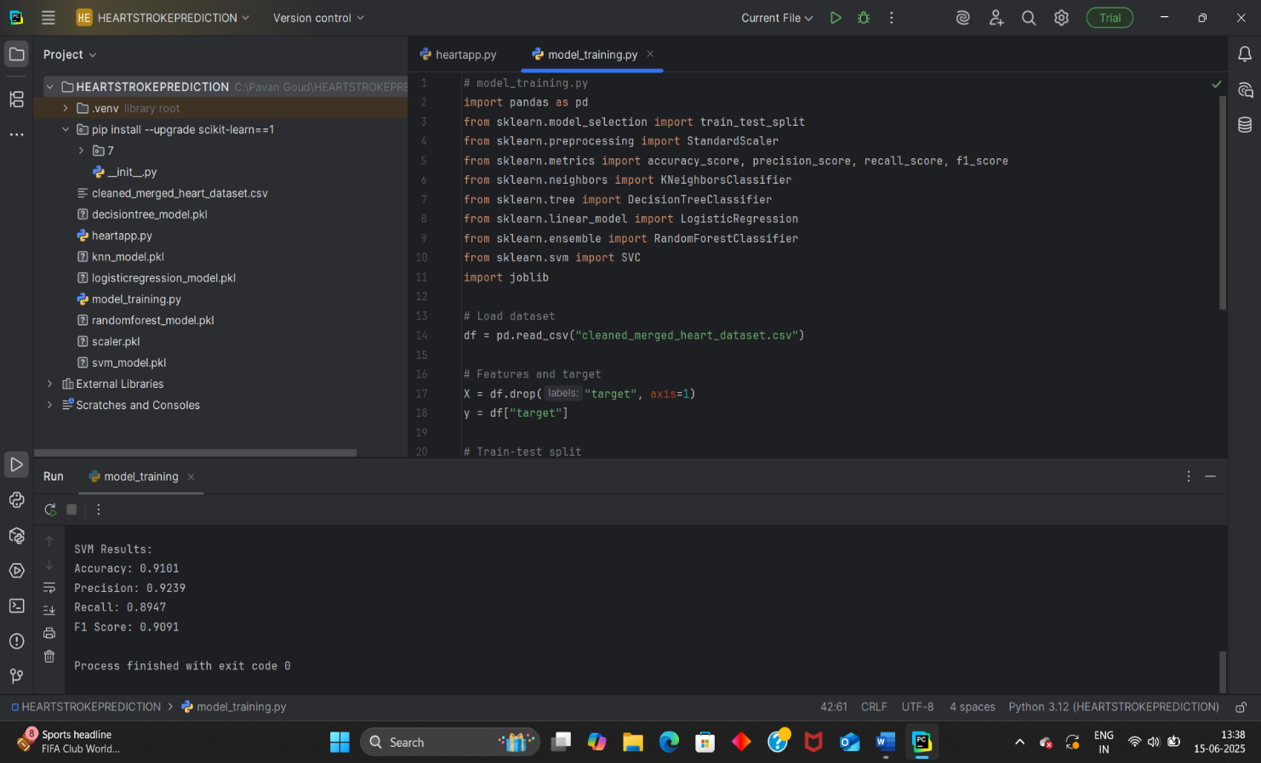

Fig:B2-trained models

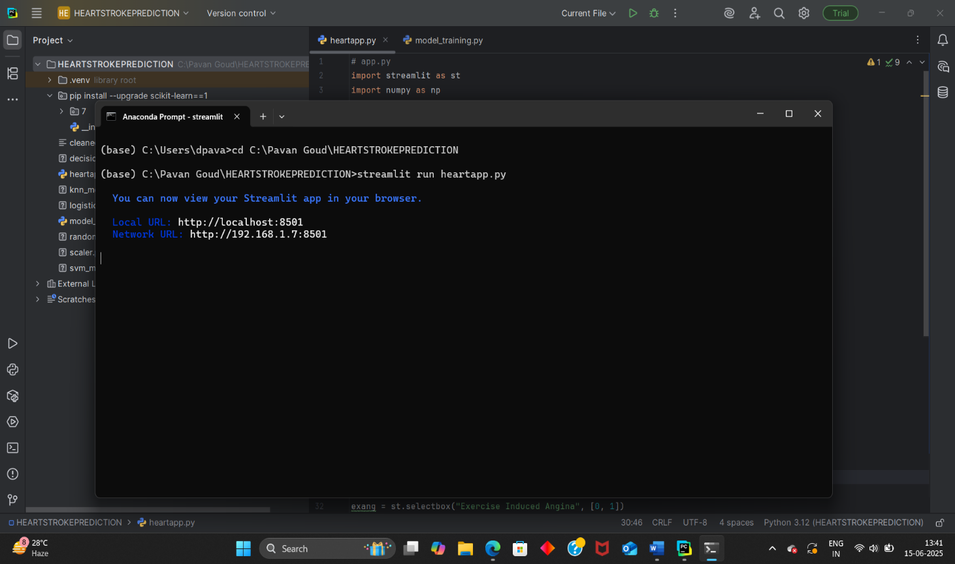

Fig:B3-Running the app

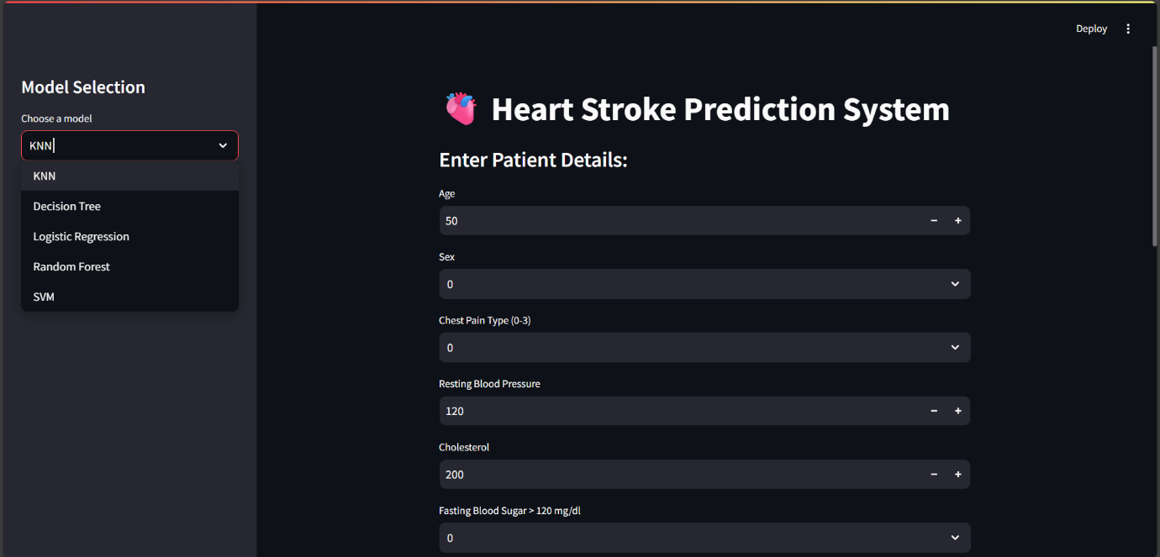

Fig – B4-Getting input data

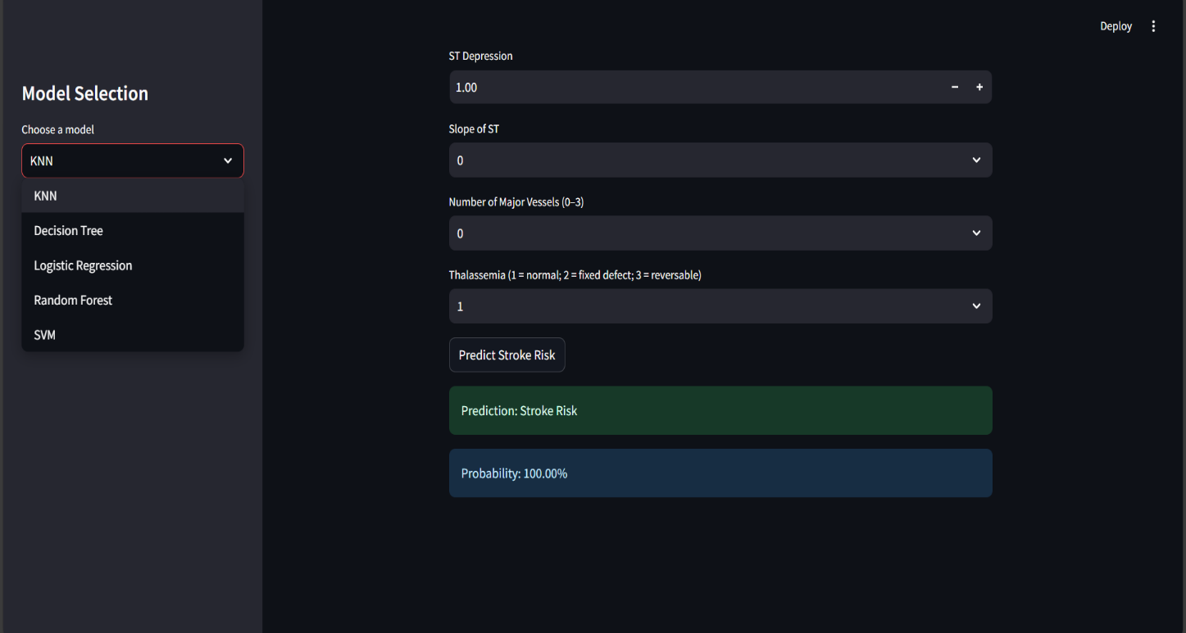

Fig-B5- output

RESEARCH PAPER
